Basic Research Techniques with Mice and Rats

Table of Contents
Handling and Restraint 2
Handling 2
Restraint 3
Commercial restrainers 3
Manual restraint of mice 4
Manual restraint of rats 5
Sex Determination 6
Animal Identification 7
Injections 8
Syringe Technique 8
Maximum volumes for injection (for normal adult animals) 9
Intravenous 10
Intraperitoneal 11
Intramuscular 12
Subcutaneous 12
Intradermal 13
Blood Collection 14
Safe volumes for blood collection: 14
Sites for blood collection: 14
Procedure for cardiac puncture 15
Procedure for blood collection From the tail vein 15
Procedure for blood collection from the saphenous vein 16
Procedure for blood collection from the mandibular vein 17
Oral Gavage 18
Euthanasia 19
Procedure for euthanasia by overdose of anesthetic 19
Sodium Pentobarbital 19
Procedure for CO₂ Euthanasia 19
Physical Methods of Euthanasia 22
Carcass disposal 22

Handling and Restraint
Mice and rats are very small animals so always be aware of how much force you use while handling them! Most mice and rats that are bred for research are relatively easy to handle. With a little practice, anyone can learn to safely and humanely handle these laboratory animal species by following these guidelines.

Handling
1. The first step in handling a rodent is to conduct yourself in a calm and quiet manner. Loud noise and sudden movements will frighten mice and rats causing them to try to run away or possibly bite.

2. Next you will need to capture the animal, most likely by grasping the tail. Mice and rats can be gently held and lifted by the base of their tails. Never lift a mouse or rat by the tip of its tail as this can be painful and cause serious injury.
Grasp here (or closer to the body)

Never here!

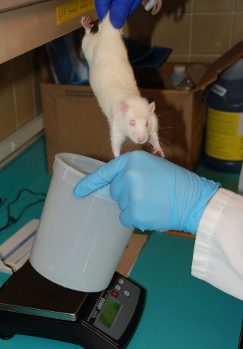

3. If you are transferring the animal a short distance (for example from its cage to a balance) it is acceptable to do so by the tail. If you are moving the animal for a greater distance (across a room) you should move the animal in its cage.

Restraint
With both mice and rats it is possible to cause asphyxiation if the animal is held to tightly. Always pay attention to the animal’s breathing and color during restraint.
Restraint is stressful to an animal and therefore you should minimize the duration of the restraint by having all of your materials ready in advance.

Commercial restrainers
Commercial restrainers are usually shaped like a cylinder or tunnel. Some use head first entry, some are tail first. The tail first variety usually provides better access to the tail for tail vein injections or blood collection. This type of restrainer can also easily be made from common items in the lab such as conical tubes and syringe cases. Another commonly used restraint device is the decapicone. The animal is placed nose first into the cone, then the plastic is secured behind them with a twist-tie or tape. If you plan to restrain a rodent in a decapicone, conical tube, or syringe case more than momentarily, create some holes in the plastic for ventilation so the animal doesn’t overheat.
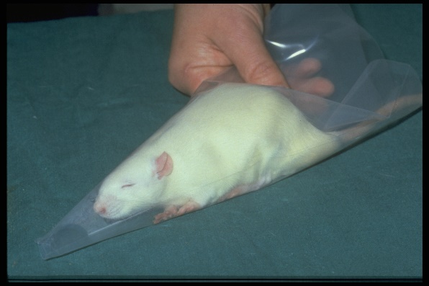
Decapicone
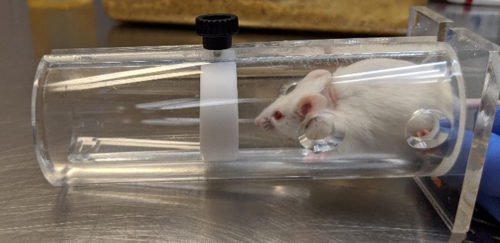

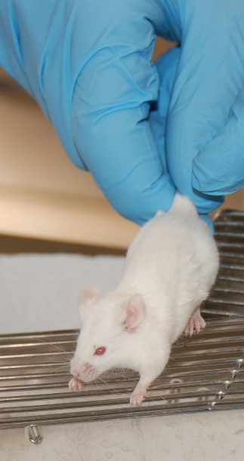
Manual restraint of mice

1. Hold the mouse by the base of the tail and remove it from its cage. Place the mouse on a surface which it can grab onto (wire bar lids work well). The mouse will naturally try to pull away from you.

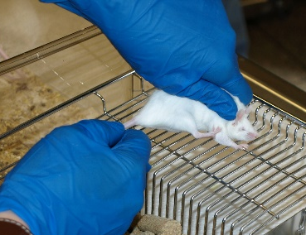
2. With your non-dominant hand, gently press down on the scruff of the neck and gather the loose skin between your thumb and first finger. Using gentle pressure will prevent the mouse from backing up behind your fingers and give you enough time to correctly place your fingers as needed.

3. Lift the mouse by the scruff and tuck the tail beneath your 4th or 5th finger. The mouse is now completely restrained with one hand.
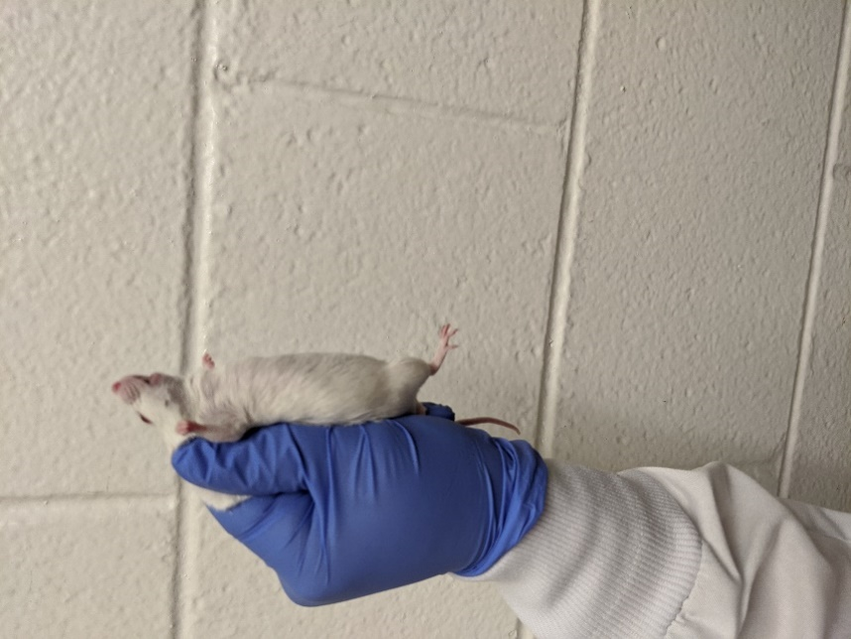
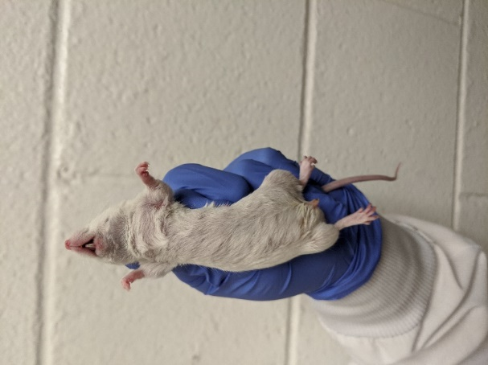

4. Once the mouse is restrained, double check that you are not holding the mouse too tightly and it is breathing normally.

Manual restraint of rats
Rats are stronger then they look! They can deliver a serious bite, and also have the ability to reach up and scratch you with their hind toenails. If you are unsure of your ability to restrain a rat, use protective gloves.
Rats will become tamer and easier to handle with frequent gentle handling.
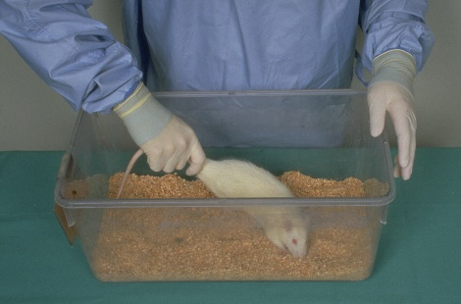
1. Before handling the rat it is helpful to calmly touch it on the back. This will eliminate the possibility of startling the rat and also give you a general idea of the rat’s disposition.

2. In the cage bottom, hold the rat by the base of the tail. It will naturally try to move in the opposite direction – this is what you want the rat to do. If the rat turns towards you, gently lift it off the cage floor and set it back down.

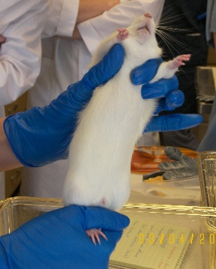
3. Move your other hand into position above the rats back.

There are 2 recommended hand positions:
- Position your thumb so that it is under one front leg, the index finger is by the neck and the middle finger is under the other front leg.
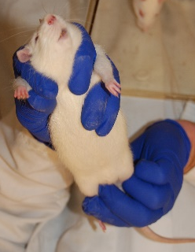
- Position your thumb and ring finger beneath the rat’s front legs and your 2nd and 3rd finger around the neck.

4. In one smooth movement you will press down gently (to prevent the rat from turning or backing up), position you fingers around the rat and lift it from the cage. It is important that you do not let go of the tail or the rat will bring its rear legs up to your hand. This will result in scratches to your hand and broken toenails on the rat.

5. Once the rat is restrained, double check that you are not compressing the thorax and the rat is breathing normally.

Sex Determination

The gender of mice and rats can be determined by looking at the anogenital distance, or the distance between the anus and genital opening. Females will have a short anogential distance as compared to males. Adult females may also have visible nipples, however this should not be used to determine the sex as the nipples are not always clearly visible on weanlings.
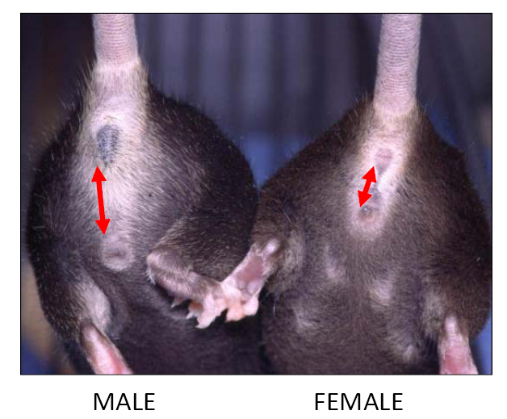
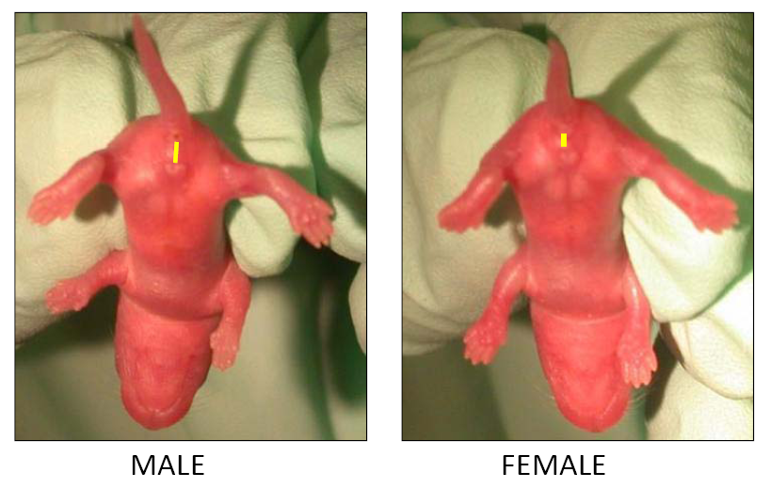

Animal Identification
There are several options for animal identification. Each has advantages and disadvantages that should be evaluated when choosing a method.
Method | Pro’s | Con’s
Cage card only | Easy, no equipment required | Must single house, possible loss of cage card
Ear tag | Simple procedure | Infection, loss of tag, animal must be restrained to read ear tag
Ear punch | Simple procedure | Possible loss of ID (torn ear)
Tail Tattoo | Permanent, easy to see without handling the animal | Expensive equipment
Toe Tattoo | Permanent, inexpensive | Animal has to be picked up to see the tattoo.
Microchipping | Permanent, scanners can work with software to store other information such as weight, study group, etc. | Scanners are expensive, however there are some available for you to borrow.

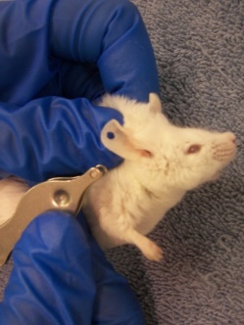
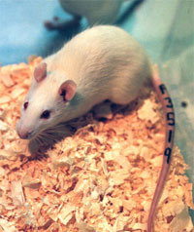
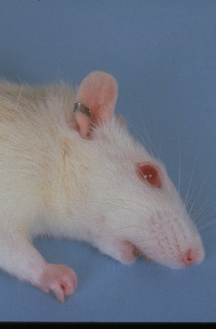
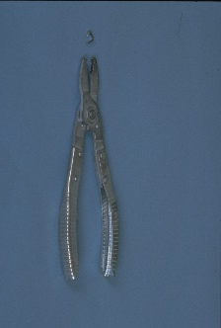

Injections
Needles should always be disposed of in a sharps container. Do not re-cap needles!

Syringe Technique
You should be able to manipulate the needle and syringe with one hand without the needle moving. Syringe size is dependent on the amount of fluid to be administered, ideally the amount needed should be in the middle of the syringe. With your dominant hand, the syringe can be held between your thumb and index finger, leaving your other three finger free to manipulate the plunger during injections.

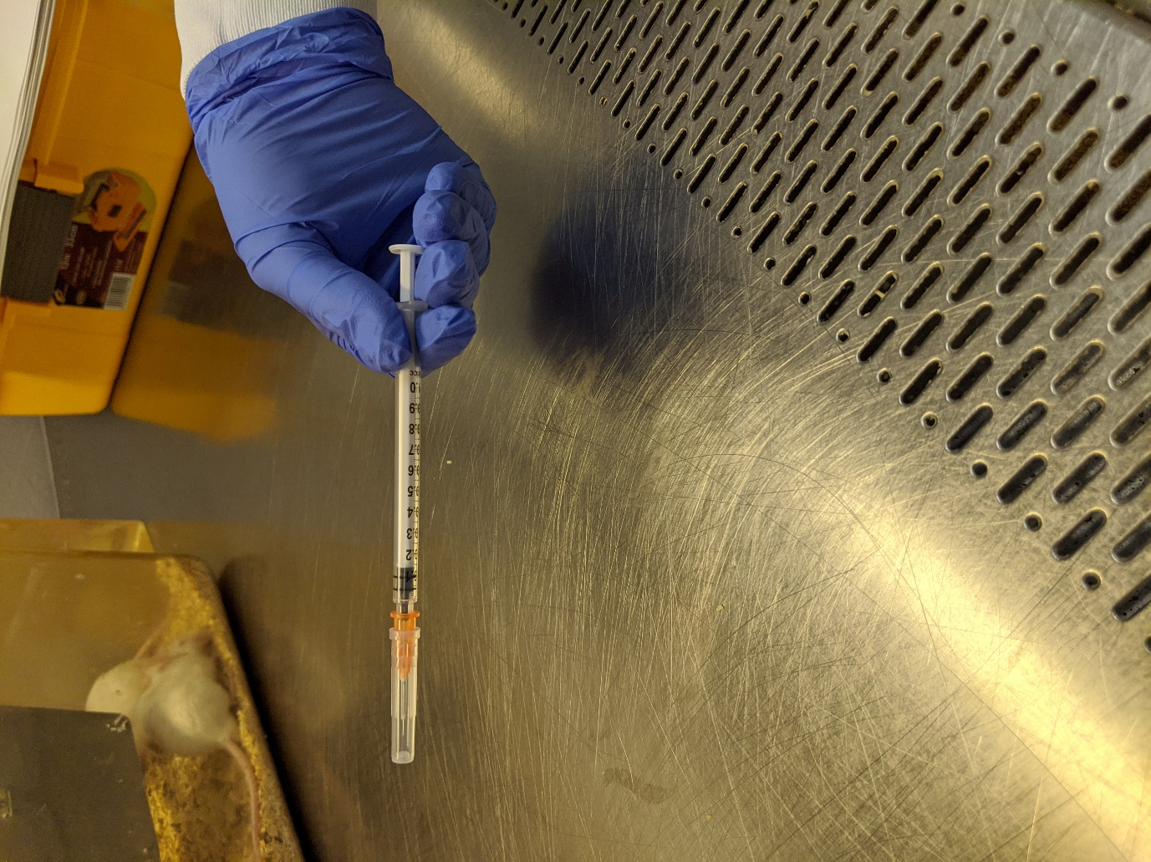
Needle w/ cap syringe plunger
Hub
Shaft
Bevel
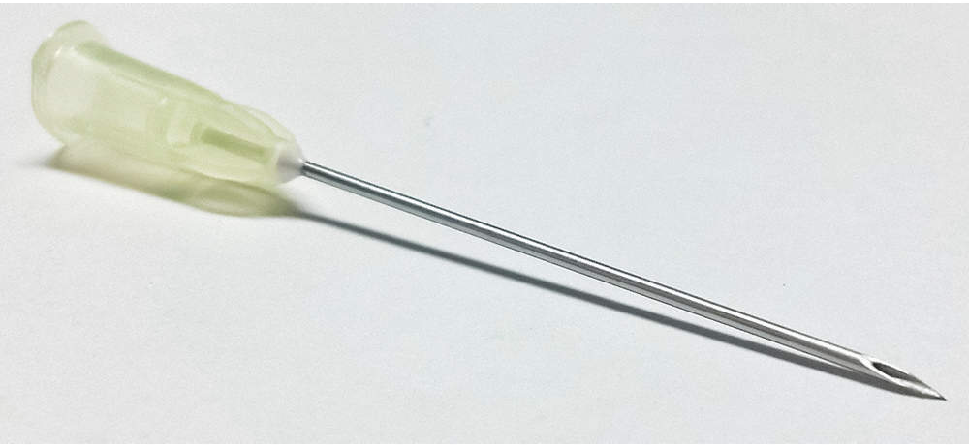

Maximum volumes for injection (for normal adult animals)

 | IV (slow injection) | IP | IM (per site) | SQ (per site)
Rat | 4 ml | 4 ml | 0.2 ml | 2 ml
Mouse | 0.5 ml | 2 ml | 0.1 ml | 1 ml

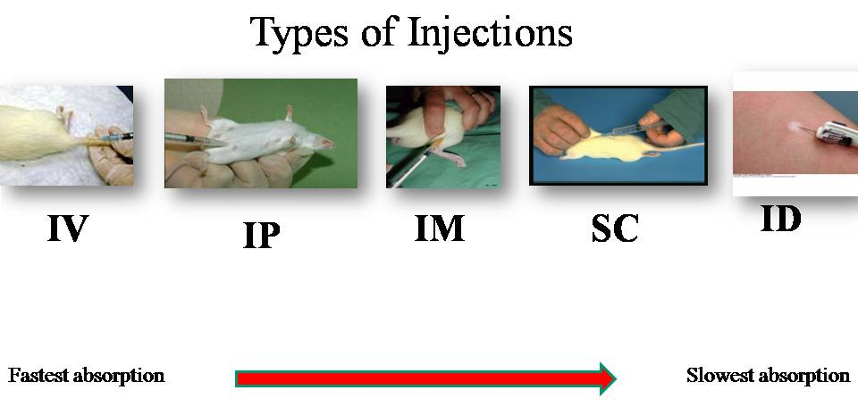

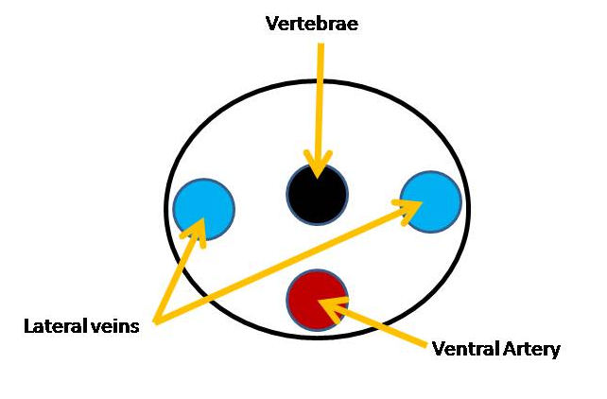
Intravenous
IV injections can be given to mice and rats in the lateral tail veins. This diagram represents a cross section of a mouse or rat tail.

Recommended needle size for Rat: 25-21 gauge/ Mouse: 30-25 gauge
1. Apply heat with a heating lamp, heating pad or by dipping the tail into a beaker of warm water. Always test the temperature first to prevent burning the animal. If a heat lamp is used the animal must be closely monitored for signs of heat stress.
2. After gathering all needed materials, restrain the animal with a restrainer, decapicone or sedation and place the animal on its side. If you are using a restraint device it will be necessary to secure the restrainer to the table with tape to prevent it from recoiling when you hold the tail.
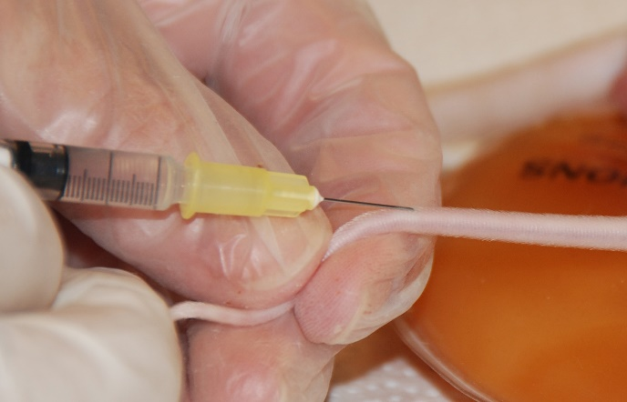
3. Use alcohol to clean the area and improve visibility of the vein. Older rats have a scaly substance on their tails called sebum. It is very difficult to remove without using a special chemical to dissolve it, so do not attempt to scrub this off of their tails.
4. Visually locate the vein and puncture it with the bevel pointed up. These veins are very superficial, so your needle will be almost parallel to the tail.
5. Using very gentle pressure, aspirate to ensure placement in the vein. It is not always possible to aspirate blood without collapsing these small veins. Alternatively, you can begin the injection with very slight pressure. If there is any resistance it indicates that you are not in the vein. If you are in the vein the injection will be visually obvious as it displaces the blood in the vein, and the plunger will depress with very little resistance.
6. After puncturing a vein you must apply pressure until bleeding stops. This can be done manually, or with a bandage.

Intraperitoneal
Recommended needle size for Rat: 25-22 gauge/ Mouse: 27-25 gauge
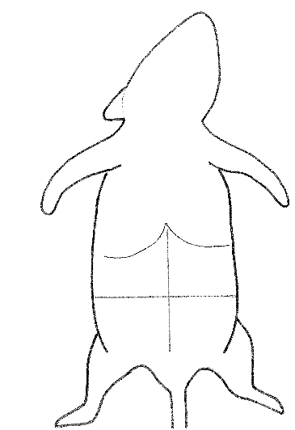
IP injections are commonly used in small rodents. The absorption rate is virtually as fast as an IV injection, and IP injections are easier to administer. However, unlike an IV injection, the material being injected IP must be non-irritating and of neutral pH. Short needles are preferable for IP injections to minimize the risk of penetrating the viscera. A 1/2 or 5/8 inch needle is appropriate.
Injection sites
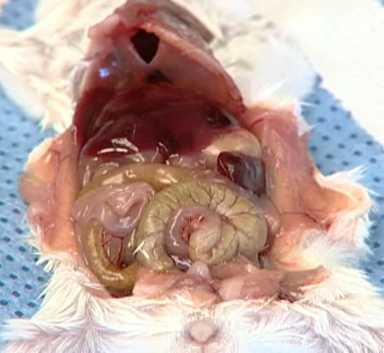
Liver
Stomach
Spleen
Bladder

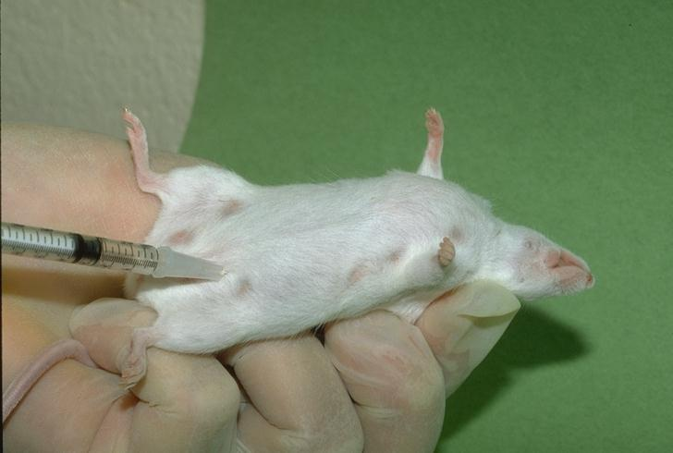
It is important to understand the animal’s anatomy to correctly inject into the peritoneum. First, palpate the animal to determine the cranial and caudal boundaries of the abdomen. Then imagine lines dividing the abdomen into four equal quadrants. The liver, stomach and spleen are located in the upper half of the abdomen, and the urinary bladder is located along the midline of the lower half of the abdomen. All of these structures are avoided by injecting into either the lower left or lower right quadrant.
1. Restrain the animal with the head pointed down. This reduces the risk of puncturing an organ by moving the viscera towards the diaphragm. For rats, this may require two people, one to restrain and one to inject.
2. Visually identify the appropriate injection site in the lower left or right quadrant.
3. Puncture the skin and abdominal wall at a 45 degree angle.
4. Aspirate to ensure placement. In a normal animal, no fluid should be present in the peritoneum. If you aspirate any fluid, there is a chance you have punctured an internal organ such as the urinary bladder, uterus or intestines. Do not continue with this injection (discard the syringe and start over) as you could introduce enteric bacteria into the peritoneum and cause an infection.
5. Once you have verified correct placement of the needle the injection can be quickly administered.

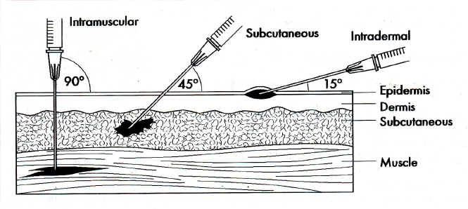

Intramuscular
Recommended needle size for Rat: 27-25 gauge
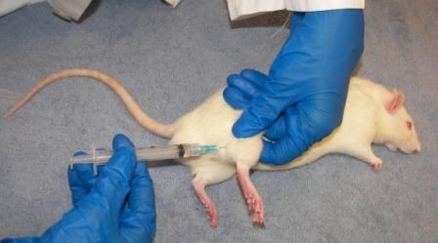
IM injections in any animal should be administered into a large muscle mass. The best site for IM injection in mice and rats is the upper hind limb. It is important to understand the anatomy and palpate the injection site to avoid trauma to any nerves, vessels or bones. It is difficult to correctly perform an IM injection in a mouse. Other routes should be considered first. When giving an IM injection, aspirate first to ensure that you haven’t accidentally entered a blood vessel.

Subcutaneous
Recommended needle size for Rat: 25-22 gauge/ Mouse: 27-25 gauge
SQ and SC are both abbreviations for subcutaneous injections. Mice and rats, like most animals have enough loose skin to easily administer a SQ injection most anywhere on the body.
Mice: SQ injections are typically administered in the scruff of the neck or inguinal region. The injection side in the scruff of the neck is not permitted in any BSL-3 work.
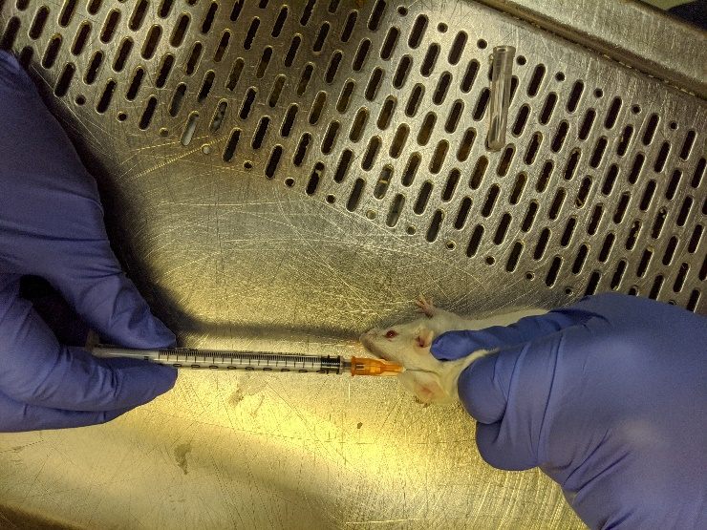
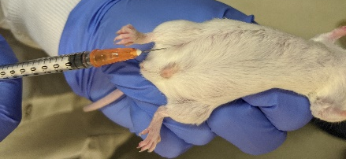
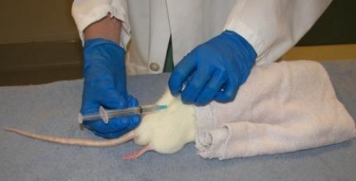
Rats: SQ injections are commonly administered in the hind quarters.
1. Tent the skin, creating a pocket to inject into.
2. Carefully insert the needle through the skin, being careful to not insert the needle too far. This would result in going through the other side of the tent of skin (which results in an Intra-fur injection!). The needle should be inserted at a very small angle, too much of an angle will result in an IP injection.
3. Inject. Use multiple sites if a large volume will be injected. Depending on the speed and volume of injection, you may see a small blister form under the skin. This should disperse quickly, if it remains longer than a few seconds your injection was intradermal not subcutaneous.

Intradermal
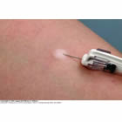
Recommended needle size: 30-25 gauge
ID injections are easiest to perform on a shaved site under light sedation.
1. Stretch the skin to create a taut surface.
2. Insert the needle parallel to the skin with the bevel pointed upwards.
3. Inject. If your needle placement is correct you will see a blister form.

Blood Collection
Needles should always be disposed of in a sharps container. Do not re-cap needles!

Safe volumes for blood collection:
As a general rule, the blood volume of an animal is about 6-8% of their body weight in grams. It is safe to withdraw up to 10% of an animal’s blood volume during a single collection.
For example; a 400 gram rat would have an approximate blood volume of 28 milliliters and a maximum safe volume to withdraw would be 2.8 milliliters.
The minimum recovery time between large blood draws is 3-4 weeks.

Sites for blood collection:

Collection Site | Volume | Anesthesia | Needle Size (gauge) guidelines | Other
Cardiac puncture | Very large | Required | Mouse: 25-22 Rat: 22-21 | Terminal procedure
Tail vein | Small/ Moderate | Not required | Rat: 25-21 | Warm animals
Jugular vein | Large | Not required, but very helpful | Mouse: 26-25 Rat: 25-23 | Difficult, will require a lot of practice
Saphenous vein | Small | Not required | N/A | Warm animals
Mandibular vein | Moderate/ Large | Not required | N/A | Do NOT warm animals

Procedure for cardiac puncture
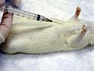
1. Position the fully anesthetized, or freshly euthanized mouse or rat in dorsal recumbency.
2. Insert the needle beneath the rib cage at a 45 degree angle.
-or-
1. Position a fully anesthetized, or freshly euthanized mouse or rat in right lateral recumbency.
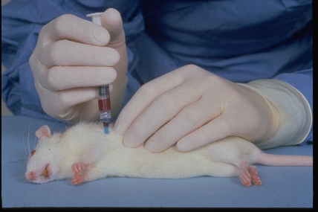
2. Insert the needle at the point where the elbow lies on the rib cage at a 90 degree angle.
3. Gentle backward pressure should be kept on the syringe plunger at all times, it is possible to collapse the heart with too much pressure. If blood is not easily aspirated, the needle can be carefully repositioned.
4. If the animal doesn’t die from blood loss during the procedure, it must be humanely euthanized.
Cardiac puncture can be used as a means of secondary euthanasia if enough blood is collected. The required amount of blood for exsanguination is approximately half of the total blood volume.
Mice: ~ 1 mL
Rats: ~ 10 mL

Procedure for blood collection From the tail vein
1. Warm the animal to cause vasodilation by one of these methods
- Place the animal in a cage beneath a heat lamp for a few minutes. Carefully monitor the temperature of the cage and observe the animal for heat stress.
- Place the animal in a restrainer. Lower the tail only into a beaker of warm (not hot) water for a minute or two.
- Place the animal’s cage on the heating pad for several minutes. This method may take a little longer than others.
2. Position a restrained animal on its side, and secure the animal to the table.
3. Apply alcohol to the tail to clean it and improve visibility of the vein. Older rats have a scaly substance on their tails called sebum. It is very difficult to remove without using a special chemical to dissolve it, so do not attempt to scrub this off of their tails.
4. Use one of the following methods to collect the blood. Puncture the vein about 2/3 from the base of the tail (1/3 from the tip). If it is necessary to puncture a second time you can move 1/4 inch proximally from the initial site. Make sure the alcohol has dried first so that it doesn’t come in contact with the blood sample.
- Mice: Nick the vein with a scalpel blade. Blood can then be collected from the tail as it comes to the surface. Applying petroleum jelly at the blood collection site will cause the blood to bead, making it easier to collect.
- Rats: Insert a needle or butterfly catheter into the vein, parallel to the tail. Blood can be collected from the end of the needle, or a syringe can be attached and blood can be gently aspirated.
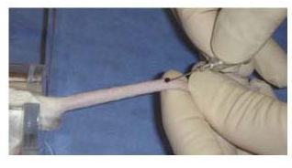

4. When you are finished apply pressure to the venipuncture site until the bleeding has stopped. Observe the animal for a moment after returning it to its cage to ensure that the bleeding doesn’t resume. Do not place animals back in warm cage as the venipuncture site may start bleeding again, instead place them in a clean, “cool” cage.

Procedure for blood collection from the saphenous vein

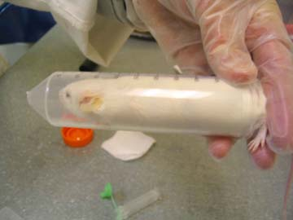
1. Warm the animal to cause vasodilation with a heat lamp or heating pad. Carefully monitor the temperature and observe the animal for signs of heat stress.
2. Restrain the animal. Typical restrainers don’t allow access to the rear legs. A good alternative is to use a 50 ml conical tube for mice.
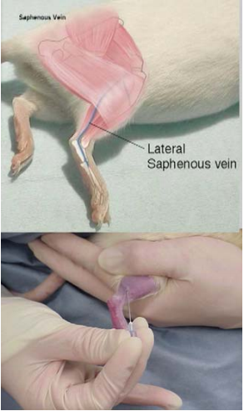
3. Shave the lateral hock area and apply alcohol. Make sure the alcohol has dried first so that it doesn’t come in contact with the blood sample. Applying petroleum jelly at the collection site will cause the blood to bead, making it easier to collect.
4. Apply gentle pressure on the leg to occlude the vein. Puncture the vein with a needle or lancet.
5. Collect blood as it comes to the surface.
6. When you are finished apply pressure to the venipuncture site until the bleeding has stopped. Observe the animal for a moment after returning it to its cage to ensure that the bleeding doesn’t resume.

Procedure for blood collection from the mandibular vein
Mice should never be warmed before this procedure.
1. Manually restrain the animal. Scruffing the mouse will occlude the vein causing it to distend.
2. Puncture the vein with a lancet or needle.
3. Collect blood as it comes to the surface.
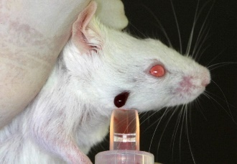
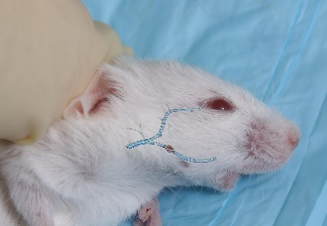
4. When you are finished apply pressure to the venipuncture site until the bleeding has stopped. The most efficient way to do this is by pinching the skin at the venipuncture site with a piece of gauze. Observe the animal for a moment after returning it to its cage to ensure that the bleeding doesn’t resume.
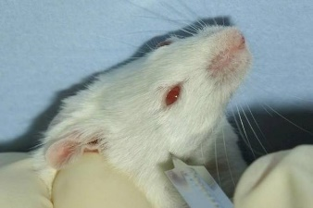

Oral Gavage
The maximum dose for oral gavage is 10ml/ kg; approximately 0.3 ml for a 30g mouse and 3 ml for a 300g rat.
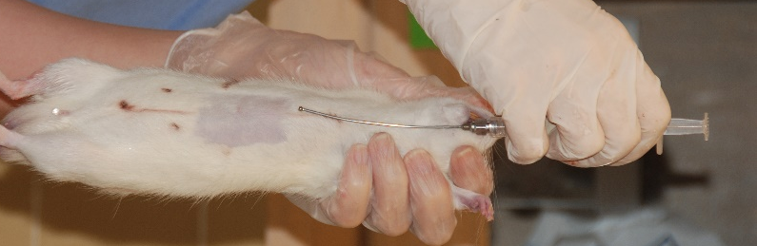
1. Proper restraint is vital for oral gavage. The animal’s head must be completely immobilized with the neck fully extended. You cannot safely gavage a squirming rodent! Once restrained hold animal with head pointed upwards.
2. With the correct size gavage needle, measure the distance from the tip of the nose to the bottom of the rib cage. This will indicate how far the needle will be inserted so that it is in the stomach.

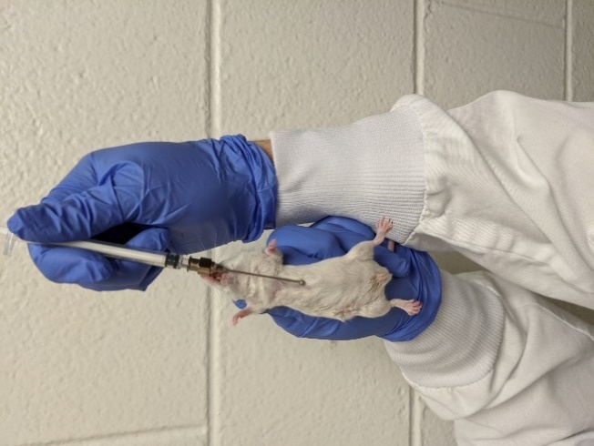
3. The gavage needle is passed over the tongue and then positioned parallel to the animal’s neck. For mice, you will gently tip the head back with the gavage needle before advancing it. The needle should only be advanced if there is no resistance. Be gentle when gavaging an animal. You may have to wait a moment for the animal to swallow the needle. Gently pass the needle into the stomach.

4. Once the needle is in place, depress the plunger slightly. If there is resistance, you may still be in the esophagus, try advancing the needle. Do not force the plunger.

5. After completely discharging the contents of the syringe, gently remove the gavage needle.

6. Observe the animal for any liquid coming out of the mouth, dyspnea or other signs of distress. Liquid coming out of the mouth may indicate that you injected part of the material into the esophagus or mouth. If the animal is dyspnic or distressed you should notify a veterinarian as these are signs that you may have injected material into the lungs or caused physical trauma to the animal.

Euthanasia

Procedure for euthanasia by overdose of anesthetic
Any anesthetic can be used as a euthanasia agent, including inhalants.

Sodium Pentobarbital
The most commonly used is sodium pentobarbital which is commercially available as a euthanasia agent. Always read the label to determine the correct dose for your animals. This drug may be administered IP or IV. Or if you are performing a cardiac blood collection, you may disconnect the needle from the syringe after the blood collection, then attach a syringe with euthanasia solution and inject it directly into the heart.

Procedure for CO₂ Euthanasia
1. Secure a euthanasia chamber, ideally using the home cage. Increasing animal density and mixing of different animals from separate cages in the euthanasia chamber should be avoided to decrease pre-euthanasia anxiety.
2. The volume of the euthanasia chamber (in liters) should be calculated and then divided by 2 (3.33-1.43) in order to determine the appropriate CO2 flow rate 50% (30-70%) based on the 2020 AVMA Guidelines newly recommended displacement rate. If your current flowmeter does not measure high enough for the cage, you may either set it on the highest measured flow rate, or you may move animals into a clean smaller cage to use a lower calculated flow rate-see below.
If using one of the LAR standard cages the volumes are as follows:
#1 Mouse Thoren cage: 5.8L, flow rate of 3.0 L/min (1.7-4)
#9 Mouse Thoren cage: 6.5L, flow rate of 3.5 L/min (1.9-4.5)
OptiMice cages: 6.2L, flow rate of 3.0 L/min (1.8-4.3)
#2 Rat cage: 10.4L, flow rate of 5.0 L/min (3.1-7.3)
Tecniplast SealSafe (blue & green lines): 7.6L, flow rate of 4.0 L/min (2.3-5.3)
Deep Rat Cage (e.g. Ancare R20): 26.2L, flow rate of 13.5 L/min (7.8-18.3)
Techniplast Rat/Hamster cage: 19.8L, flow rate of 10.0 L/min (5.9-13.8)
3. The cover should be placed over the euthanasia chamber/cage, and the flow meter should be checked to ensure it is in the off position. The CO2 canister valve is then turned on (A) and the pressure gauge closest to the tank should register a pressure. If there is a second gauge on your setup (B), then it should then be turned on as well (this one is usually left on each time so may not have to be adjusted). After both valves have been turned on, the flow meter can be adjusted to the appropriate flow rate (liters/min) in order to gradually introduce 100% CO2 to result in the replacement of 30-70% of the cage volume per minute. This flow rate has been shown to produce a rapid loss of consciousness without apparent pain.
4. Following the induction of unconsciousness (this will take approximately 1-3 minutes), the CO2 flow rate can be increased to accelerate the process. Following apparent clinical death of the animal (no visible respirations), gas flow should be maintained for at least one minute.
5. Following death the main tank valve should be turned off, and excess gas allowed to flow out of the tubing. Once gas has stopped flowing, turn the flowmeter valve off.
6. Cervical dislocation or bilateral thoracotomy should be performed to assure the animal will not regain consciousness.
NOTE: Neonate rodents (“pinkies”) will become anesthetized with CO2. However, due to their high levels of fetal hemoglobin, they are resistant to death via CO2. Cervical dislocation or decapitation (following CO2 narcotization) is the best method of euthanasia for these neonates.
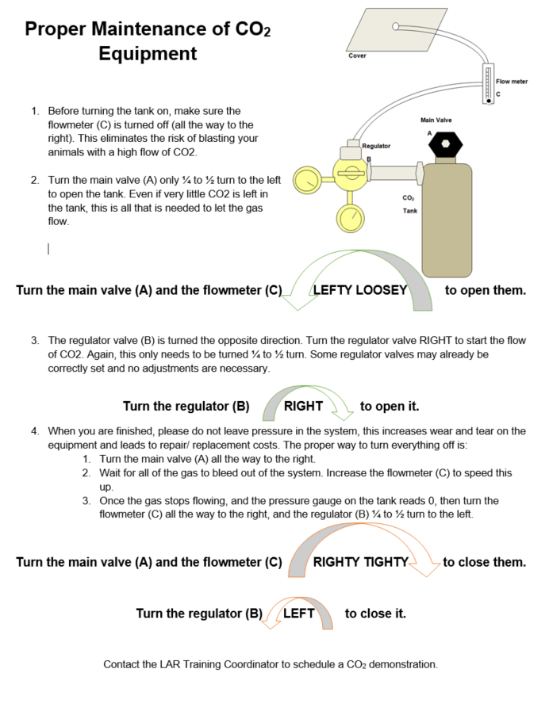

Physical Methods of Euthanasia
Physical methods of euthanasia are performed under a surgical plane of anesthesia. These methods can also be used as a secondary means of euthanasia, to confirm death after CO2 euthanasia, as required by the AVMA Guidelines for Euthanasia. Physical methods include decapitation, cervical dislocation, thoracotomy, removal of the heart, lungs or brain, and perfusion. Each of these is a specialized technique which will require training prior to performing the technique.

Carcass disposal
Animal carcasses must be disposed of properly. Do not throw carcasses in the trash.
LAR will accept small animals for incineration. Carcasses must be sealed in a leak proof plastic bag. Legibly identify the bag with the investigator’s name and any biohazards. If you are working in the Painter Center, place the bagged, identified carcass in the necropsy cooler (room D104). If you are bringing a carcass from another location, call ahead to schedule a time (during normal business hours) when cage wash staff can meet you at the dirty side cage wash dock. Do not drop off carcasses outside of the painter center without someone there to receive them.
LAR also collects rodent carcasses for wildlife rehabilitation organizations. They must be free of ear tags, implantable devices, infectious agents, chemicals and drugs. Contact LAR for more information if you will have carcasses that fit these criteria.
If you are working with animals in a BSL-2 or BSL-3 setting, additional restrictions on carcass disposal will apply. If you are unsure of the proper procedures please contact LAR for more information.
Laboratory Animal Resources (LAR) – 491-7364

